Phone: (08) 8953 4200
Shop 7 Diarama Village, Larapinta Drive, Alice Springs NT 0870

ASYASS ANNUAL REPORT 2024-2025
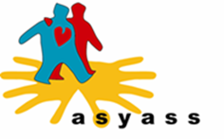

acknowledgement

Alice Springs Youth Accommodation and Support Services Inc (ASYASS) acknowledge the Arrernte people as Traditional Owners and Custodians of Mparntwe – the land on which we live and work. We pay our respects to Elders, past, present and emerging and to all First Nations Peoples of this country.

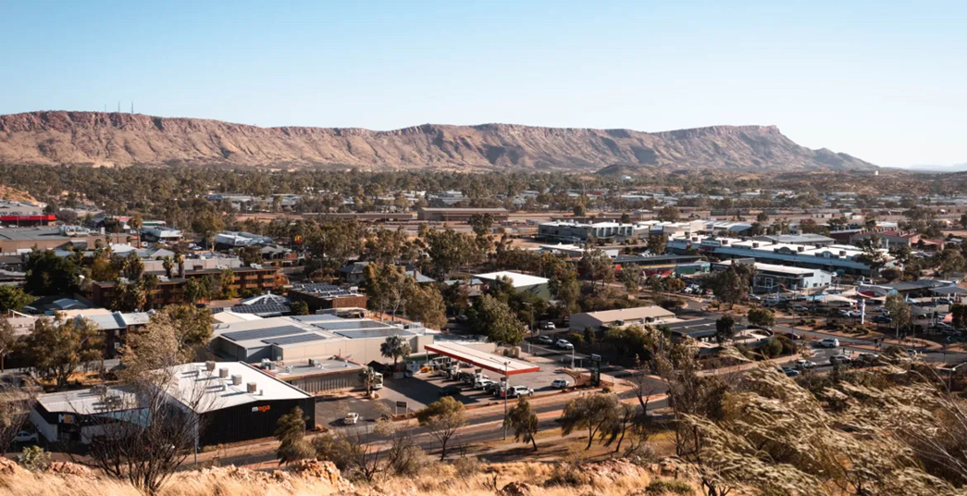

about us

ASYASS is a non-profit, community focused organization that has helped young people in Central Australia for over 30 years. ASYASS provides crisis and transitional accommodation, case management, outreach support, and advocacy to young people aged 13-25 years experiencing homelessness or at risk of homelessness and provides a range of support services to address presenting issues.

ASYASS believes that all young people should be free from discrimination and have a right to secure, appropriate and affordable housing regardless of gender, ethnicity, culture, religion, or sexual orientation.

ASYASS has four accommodation and support programs, namely:

- Ampe Akweke (Mums and Bubs): 5-bedroom residential facility for young women between the ages of 14 – 23 that are pregnant or have a child under two years old. The program provides safe, nurturing accommodation for mothers and their children and aims to empower them to grow into resilient parents, in a culturally respectful environment.

- The Crisis Refuge: 4-bedroom residential facility for males and females aged 13 – 17 years old. The program offers short- and long-term accommodation to young people experiencing homelessness and immediate crisis. The young people are encouraged and supported to engage in education and/or employment activities.

- The On Track Program: Intensive youth support facility for young people aged 16-17 years old that focuses on transitioning the young person into independence and re-engaging with the wider community, whilst living in a homely environment.

- The Youth Housing Program: Semi-independent transitional program for young people aged 16-24 years old for a 12-month period. The program manages eight properties located across Alice Springs and empowers young people towards independent living.

ASYASS assists young people facing significant barriers to securing safe and affordable housing. Many young people struggle to access the rental market due to limited or no rental history, low incomes, and age-based discrimination. The chronic housing shortage in Central Australia intensifies these challenges, leaving many young people extremely vulnerable. Young People experiencing homelessness or chronic housing-stress are often living with multiple layers of personal hardship. These can include fear, trauma, i.e., simple, complex, and chronic trauma, intergenerational family breakdown, mental health issues, financial hardship, social isolation, and extremely high rates of community, family, or domestic violence.

OUR VISION, MISSION, AND VALUES

Our Vision

The human, social, and economic rights of all young people are promoted and respected within the community.

Our Mission

To create a community where young people are treated equitably and have appropriate access to goods and services that will allow them to live safely and comfortably as valued and respected members of our society.

Values
- We value a way that will increase the sense of belonging and connectedness to the community.

- We value and respect the people we work with.

- We are flexible in response to people’s needs.

- We believe that people have the power to change their situation.

- We respect people’s differences.

- We view people in the context of their situation, their environment, and their communities.



ASYASS TEAM

Board of Management Team
The Board of Management is made up of committed voluntary members who have generously given their time, knowledge, and experience throughout the year.

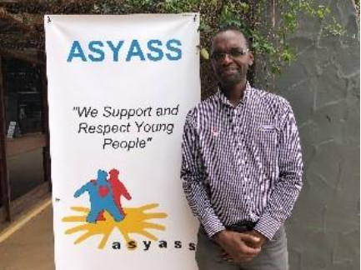
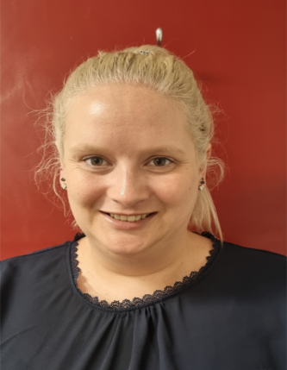

Ashlea Begg – Chairperson Temba Ncube – Treasure

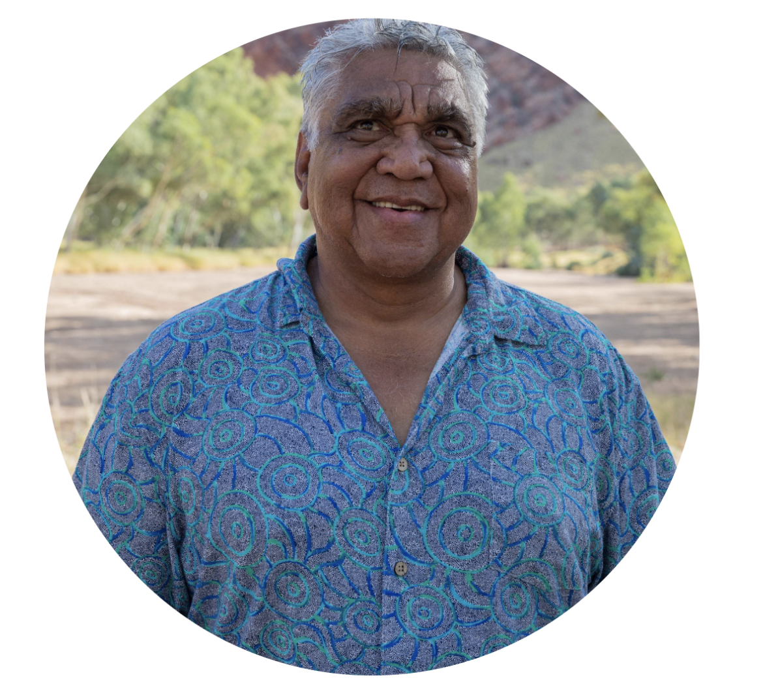


Nicholas Simmons – Secretary Faron Peckham – Ordinary member

CHAIRPERSON MESSAGE – ASHLEA BEGG

2024-25 has been another excellent year for ASYASS. On behalf of the Board, I would like to thank every member of staff for your hard work and dedication to ASYASS and to the youth of Alice Springs. We also owe a debt of gratitude to our young clients, who have taken steps to seek ASYASS’ help and support, and who engage with the programs and supports ASYASS provides.
The Board members have been working tirelessly on the Ampe Akewke expansion project for the past few years, and we are thrilled to report that funding has been granted, and we are close to securing part of the laneway next to Ampe Akewke to facilitate that expansion. Thanks go to Nick Simmons on the Board who has been doing the heavy lifting for an exceptionally long time trying to get this project up and running.
The Board also remains ever grateful to our CEO, Ojisi, for his extraordinary work. Ojisi has dedicated himself to ASYASS and it cannot be overstated just how much work Ojisi does for this organisation. CEO is a difficult job at the best of times, and in today’s economic climate it is even more taxing to head up an organisation that serves an enormous social need with a minimal budget. Ojisi has worked night and day to improve both the day-to-day operations and the strategic growth of ASYASS, and the Board thanks him for his tireless efforts.
To the Board members: Nicholas Simmons, Faron Peckham and Temba Ncube – ASYASS is all the better for your support and the countless hours you have volunteered. Thank you.
Our budget is as tight as ever, but thanks to Ojisi’s financial acumen over the past few years, ASYASS is strong enough to stay the course. We are looking forward to seeing what 2025-26 brings and continuing to pursue further funding for all our excellent programs.
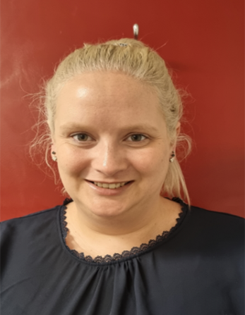
Ashlea Begg – Chairperson of the Board

CEO MESSAGE – OJISI CHARLIE
I am pleased to present this report for the 2024–25 budget year. This year has been one of strategic renewal, operational maturity and strengthened partnerships. It has also been a year of considerable progress in delivering on our purpose to provide targeted and tailored homelessness support for both children, young people and our key stakeholders, stronger evidence for better decisions, improved homelessness support and welfare outcomes for all homeless young people and children in Central Australia. We saw an increase in demand for our services, and I want to thank our staff and key stakeholders for their unwavering dedication in navigating this increased need.
I am filled with immense pride and gratitude for the incredible work we have accomplished as an organization. The year had great challenges for the children and young people we support. The commitment, the motivation, the determination, and the hope that I experience daily among the children and young people we work with, is a powerful reminder of the importance and critical work we do, at ASYASS.
For the young people we support, they experienced significant challenges in the last budget year, under review. Our work in 2024–25 continued to support children and young people with several presenting issues i.e., health issues, disability, housing, unemployment, alcohol and other drugs (AOD), domestic violence (DV), overcrowdings, and child protection issues. This report details our shared achievements, which would not have been possible without the support from our stakeholders, the resilience of our staff and the Department of Homelessness.
I am thrilled to announce that we supported over 82 young people, and two of the young people we supported who were homeless and not attending school, through targeted personalised case management practice both are gainfully employed and thriving in their jobs. This is a success story due to the direct result of the quality and tailored support we provide.
Through the quality stakeholder relationships and collaboration with our key stake holders, we provided a variety of services to assist children and young people who are/were experiencing homelessness ranging from widespread support and assistance to immediate crisis accommodation support. It is important to note that, the number of children and young people we supported reflects the quality of our engagement with children, young people, and key stakeholders to deliver quality homelessness programs in a multidisciplinary environment.
The collaboration and partnership allowed us to provide tailored, and individualised support including outreach support to non-residential clients, reaching, and engaging even more vulnerable young people at risk of homelessness who did not have easy access to support services. The integrated, wrap around service model we deliver is targeted and addresses the diverse, complex, and chronic needs homelessness young people have.
Thank you to our staff for your extraordinary efforts and to our funders for your continued generosity. Together, we are building a community where every child and young person can thrive, access safe accommodation.
In a year like no other, your wisdom and determination have ensured the ongoing success of ASYASS, and importantly greater support for the children and young people we work with. My sincere thanks to our Chair, Ashlea Begg for her leadership, vision, and brilliance, enabling ASYASS to expand and grow during this challenging climate. To our other board of Directors, Nicholas, Faron and Temba thank you for your support and unrivalled passion for the work of ASYASS.
Ojisi Charlie - Chief Executive Officer
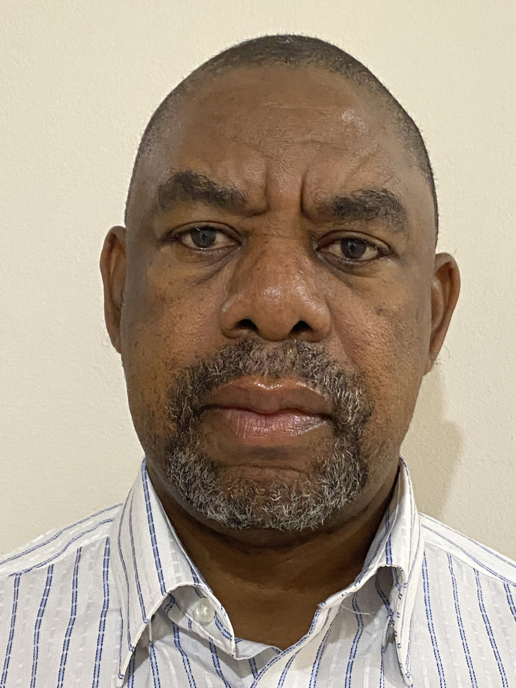

MANAGEMENT TEAM

Ojisi Charlie – Chief Executive Officer

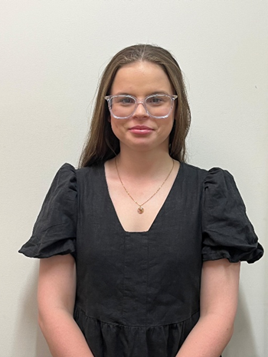

Olivia Bonora – Crisis Refuge Case Manager and Quality Assurance Officer

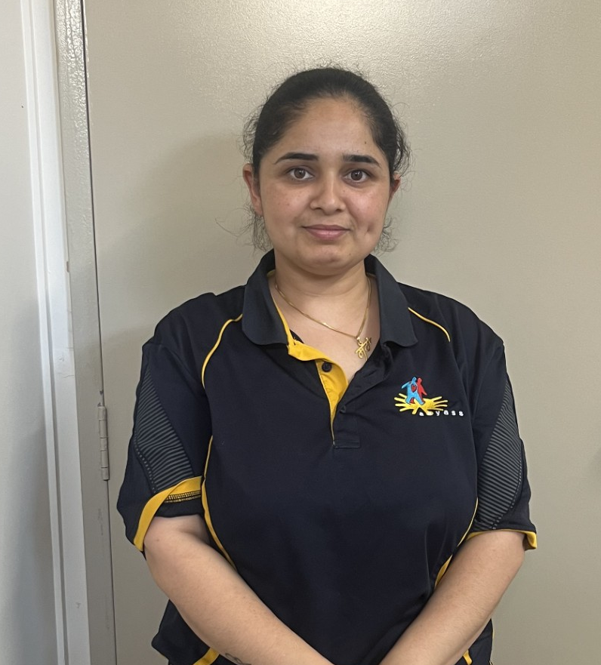
Kamaljeet Kaur – Corporate Services Manager

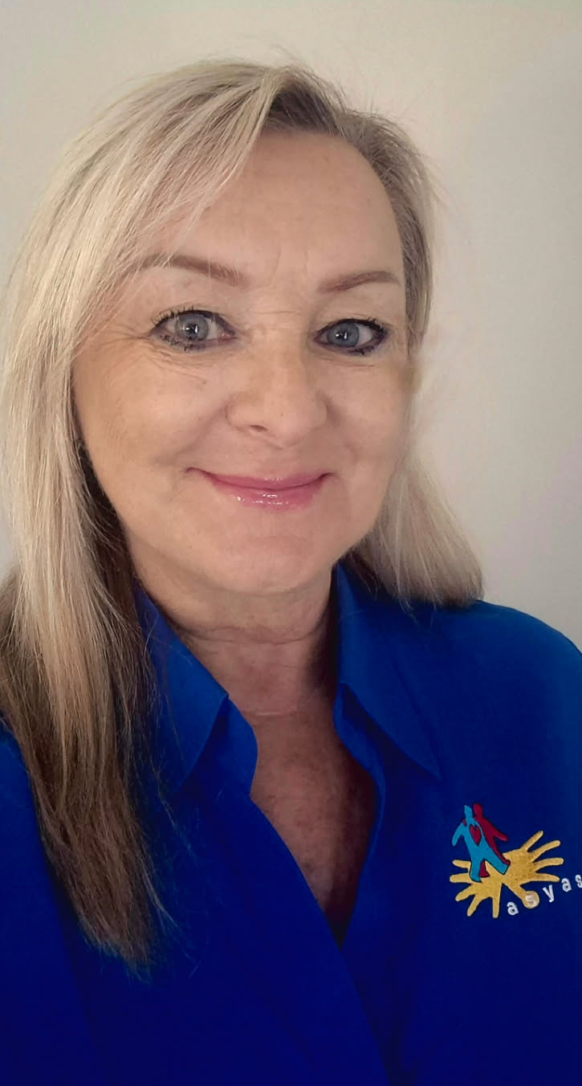

Sue Nankivell – Youth Housing Officer

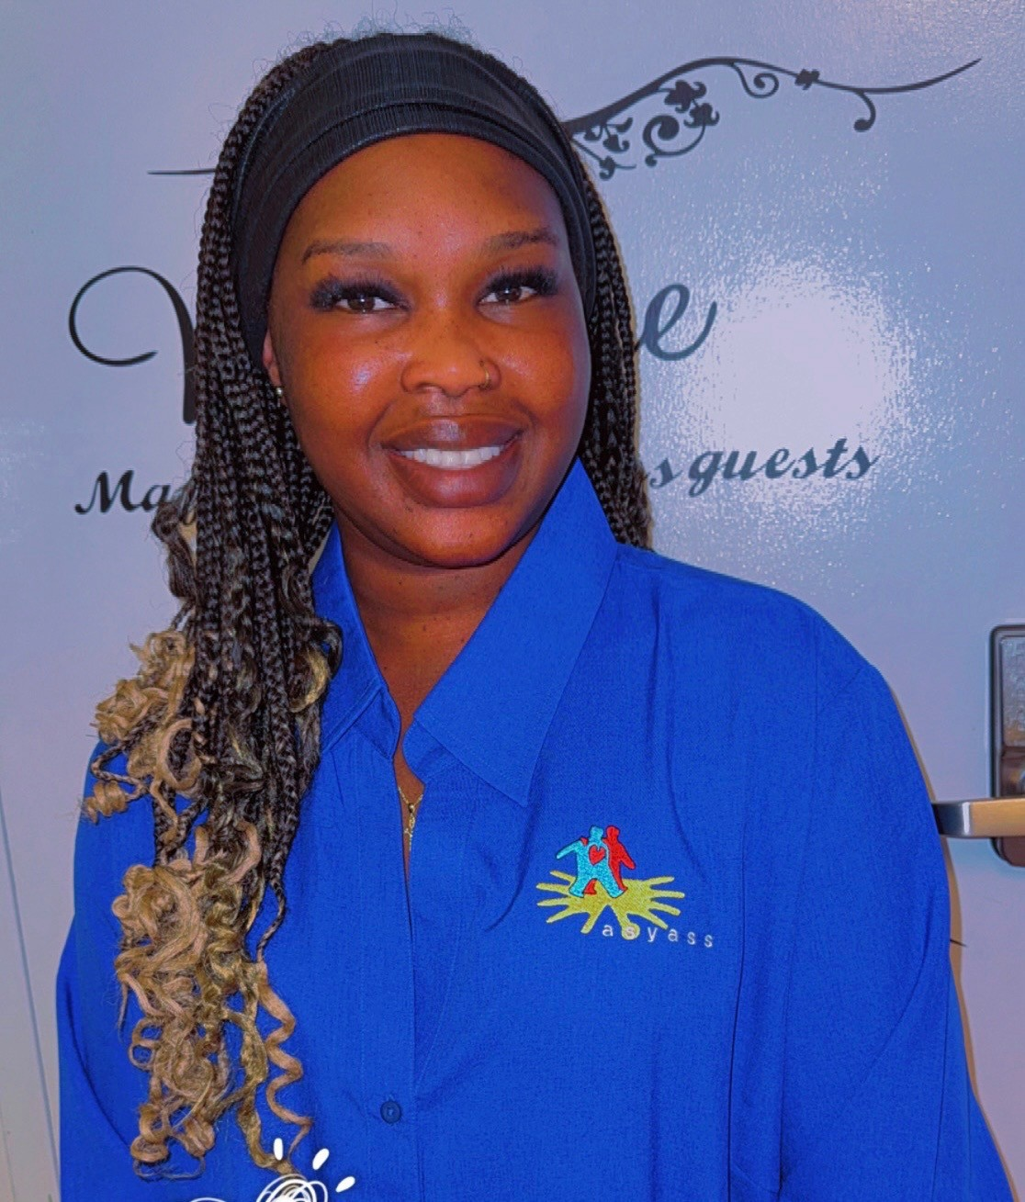
Nyidier Wieu – Ampe Akweke Case Manager


Rose Ronchetti – Senior Bookkeeper/Payroll Officer at R & R

RESIDENTIAL SUPPORT WORKERS



Alexandra Craig Catherine Fitzsimons

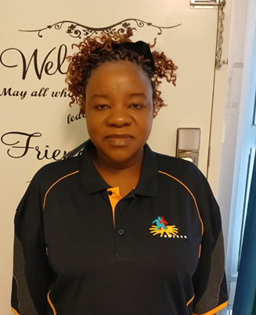


Blessing Onyeocha Chipo Chiyowela

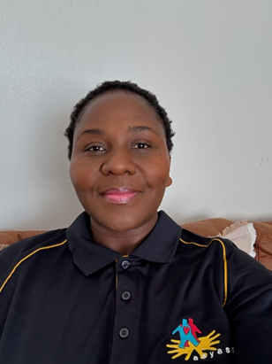
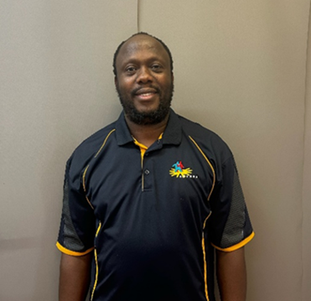

Cynthia Siwela Gift Zisengwe
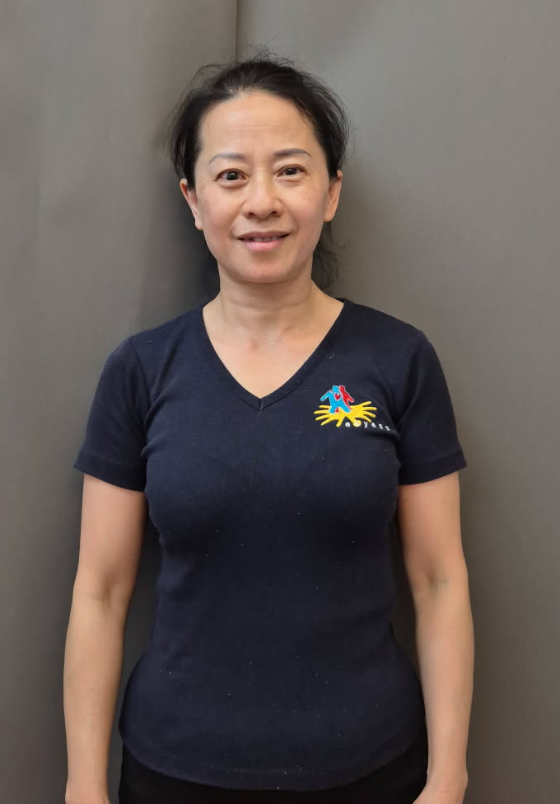


Jian Tian Maxwell Flemming
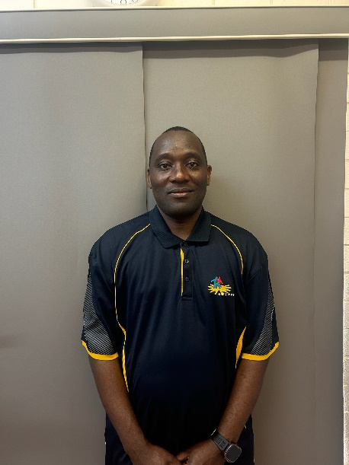
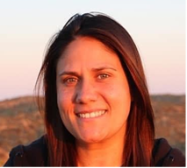

Milandu Sichokolo Morgan Lane
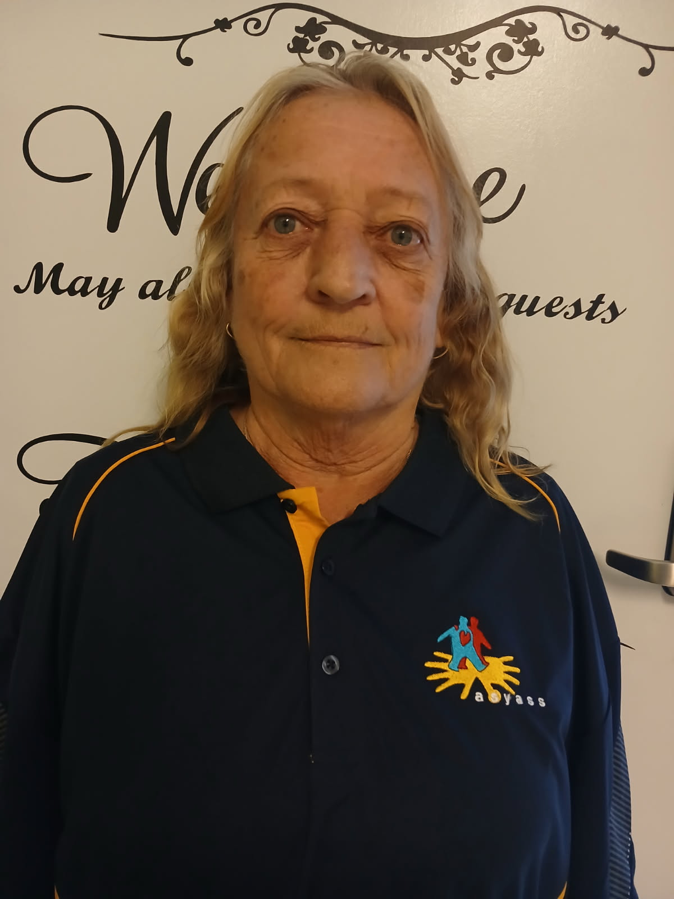
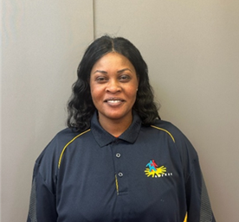

Rita Bringi Vicki St Claire

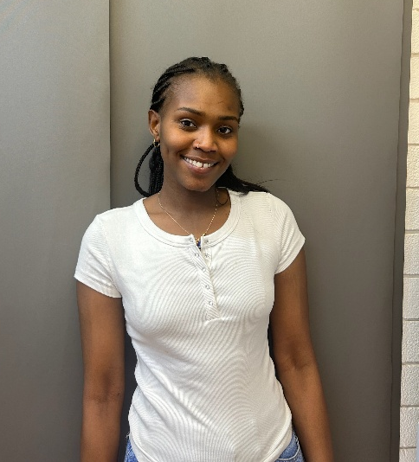
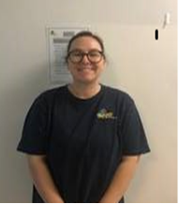

Zulfa Basha Zoe Guerin

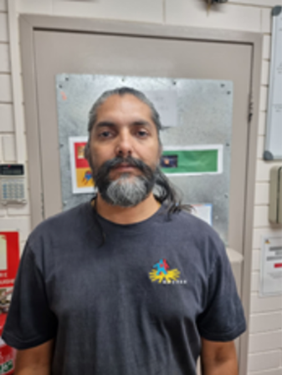

.

Birdavirk Singh – Maintenance Officer

PROGRAMS
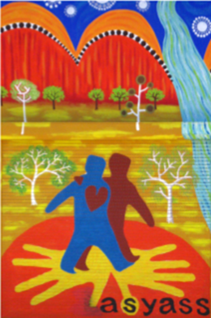
AMPE AKWEKE HIGHLIGHTS
Our Impact
In 2024–2025, Ampe Akweke proudly supported over 45 young mothers and children, offering both short and long-term housing solutions tailored to their unique needs. Beyond accommodation, we delivered comprehensive postnatal care, facilitated access to essential services including Centrelink and Medicare, and provided parenting education and life skills development. Our outreach programs offered vital resources such as laundry, nutritious meals, and a culturally safe space, ensuring holistic support for the mothers that were unable to reside in our residential facility.

Creating a Safe and Supportive Environment
Safety and cultural respect are at the heart of everything we do. Our secure facilities feature gated access and CCTV, with ongoing upgrades enhancing our residents’ comfort and security. We have created welcoming shared spaces designed to nurture wellbeing and foster connection among residents and outreach participants alike.
Ampe Akweke received funding through the Community Underwriting 2024 Small Grants Program to improve the security at Ampe Akweke. Through the grant, Hardy Fencing installed a new perimeter fencing around the property, improving overall safety, and reducing the visibility from outside, thereby providing greater privacy and comfort for our clients. Ampe Akweke was also granted funding through the Community Support Grant from Lhere Artepe. This funding is for increased security measures at the facility, including the installation of security cameras, double lock doors, and Crimsafe security screens. These improvements will contribute and create a safer, and more secure environment for staff, families, and children. The partnership with Lhere Artepe demonstrates the value of community collaboration in supporting the wellbeing and safety of local families.

Capital Project Funding from the National Indigenous Australians Agency (NIAA)

Ampe secured Capital Project Funding through the Central Australia Boarding Response Fund from The National Indigenous Australians Agency (NIAA). This funding aims to increase accommodation capacity and enhance Ampe Akweke as a safer and more supportive accommodation for young pregnant women and their children. It will enable the service to expand its service delivery to include independent living skills i.e., practical areas like money management, cooking, cleaning, and laundry, alongside crucial personal development skills such as time management, problem-solving, effective communication, setting boundaries, understanding personal safety, maintaining hygiene, building healthy relationships and goal-setting. Developing these skills fosters confidence and empowers them to manage daily life, navigate challenges, and thrive independently. This will strengthen the operational capacity and corporate management of the organization. The project is expected to have a significant impact on reducing homelessness for young pregnant women, mothers, and their children across Central Australia.

As the only dedicated organizations in Central Australia that supports youth experiencing homelessness, we have firsthand knowledge of the gaps and challenges within the sector. The current housing crisis in Alice Springs and surrounding areas has resulted in low level infrastructure, limited housing availability, and high rental costs for substandard accommodation. We are often forced to turn down referrals and maintain an extensive waiting list for accommodation places. Through this project, Ampe Akweke will be able to provide increased housing for several young mothers and their children, creating a safer and more stable environment for families in the community.

Indigenous Leaders Marion Scrymgour and Minister Malarndirri McCarthy visited Ampe Akweke and met with staff and clients, to celebrate the announcement of the funding from (NIAA) grant and to have an insight about the program’s impact and witness firsthand the positive difference the service is making for young mothers and their children across Central Australia.

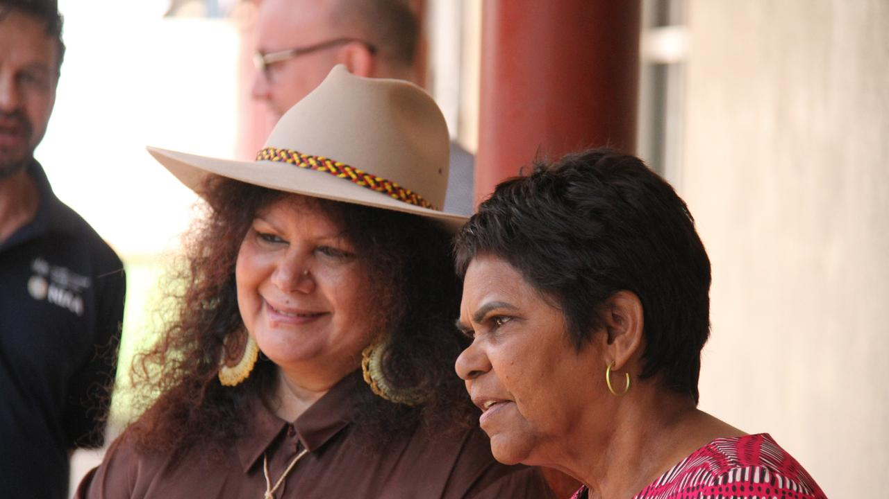
Working Partnerships and Stakeholders
We are deeply honoured to receive recognition from the Central Australian Remote Outreach Midwives, the Midwifery Group Practice Midwives at Alukura and the Australian Nurse-Family Partnership Program. Their commendation of our dedicated team for providing exceptional care, coordination, and unwavering support to vulnerable young mothers means so much to us. Their continued referrals affirm the strong foundations that Ampe Akweke helps build during early parenting, reinforcing our vital role in supporting families on their journey.
Central Australian Women’s Legal Service (CAWLS) provided fortnightly educational sessions for both the young mothers and the Ampe Akweke Staff. The sessions focused on domestic and family, sexual violence, recognising the signs of abuse, and understanding where to seek help. The workshops have been instrumental in empowering the young women and staff with knowledge, confidence, awareness, and practical strategies to promote safety and wellbeing within the community.
Ampe Akweke also partnered with Australian Childhood Foundation to provide a 6-weeklong reflective parenting program to the young mothers at Ampe Akweke called Bringing Up Great Kids. This program assisted parents to explore parenting styles on their own, learn about their child’s brain development and behaviour and discover ways to take care of themselves.
We always stay connected to the community through attending the Maternity Services Interagency Meeting which allows for networking, collaboration, and sharing information with local service providers to ensure an integrated approach is maintained for the young women and their children.

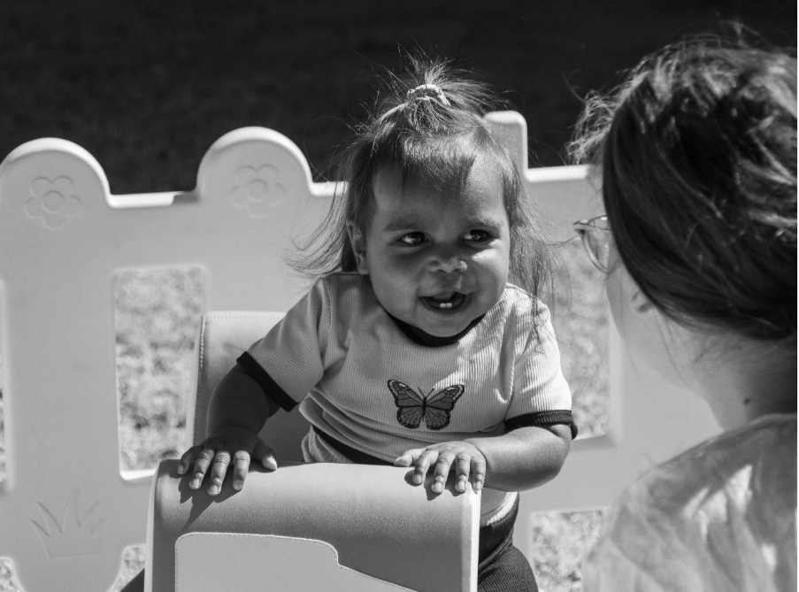

Gratitude and Commitment
We extend our heartfelt thanks to the courageous young women and families who place their trust in us, our dedicated staff and stakeholders who bring compassion and professionalism to every moment, our health partners and midwives who work alongside us, and the generous funders and community allies who make our work possible.
Together, we are shaping safer, stronger futures—one young mother and child at a time.

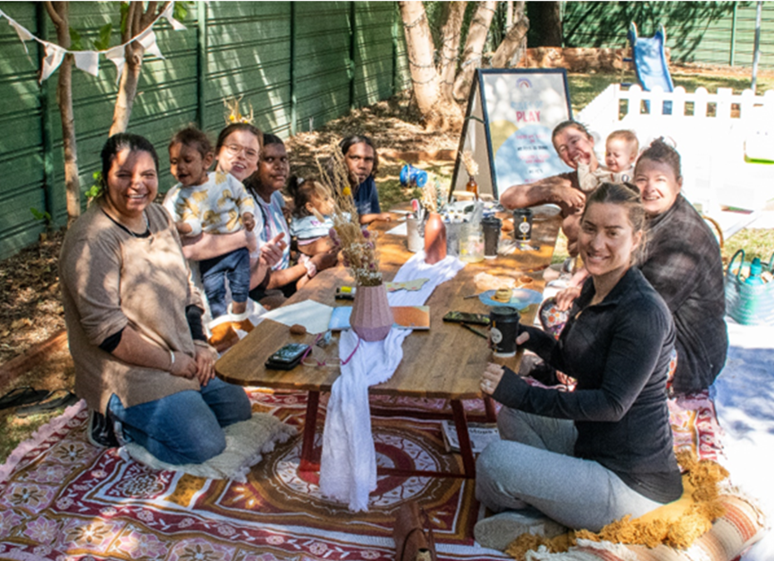

CRISIS REFUGE AND ON TRACK HIGHLIGHTS
Our Impact

The 2024-2025 year has been a demanding and impactful year for the Crisis Refuge, characterised by a consistently high demand and the need to respond to the diverse and complex needs of young people across the Central Australian community.

The Crisis Refuge supported over 17 young people, 13 of those was provided short term accommodation, one received medium term accommodation, and three young people sustained long term accommodation support at Crisis Refuge.

A significant percentage of young people successfully transitioned into long term, stable accommodation, with many re-engaging in education, training, and employment. All young people received individualised case management tailored to meet their specific needs.



Cultural Engagement
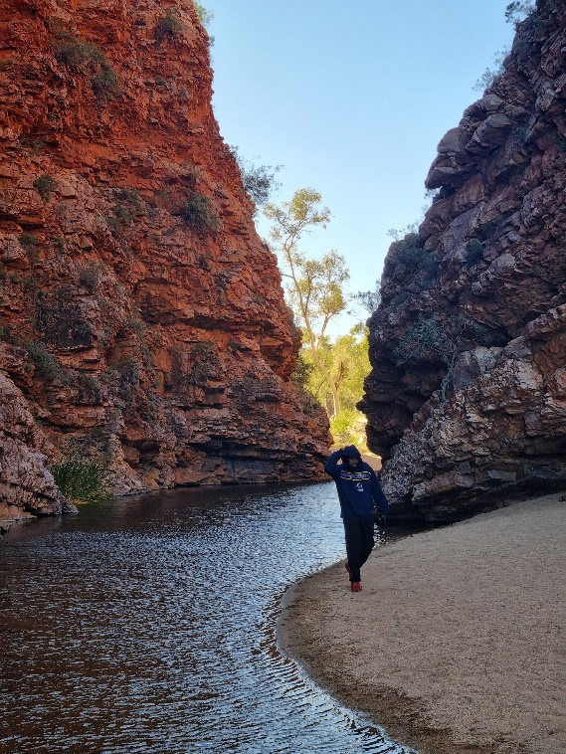
The Refuge facilitated the young people to reconnect with culture and community by supporting them to return to Country and engage in cultural practices. The young people engaged in a range of traditional activities, i.e., yarning, Kangaroo tail cooking and preparing bush foods, guided and supported by Elders. The return to Country not only supported individuals' well-being but also contributed to the ongoing cultural revitalization and self-identify.

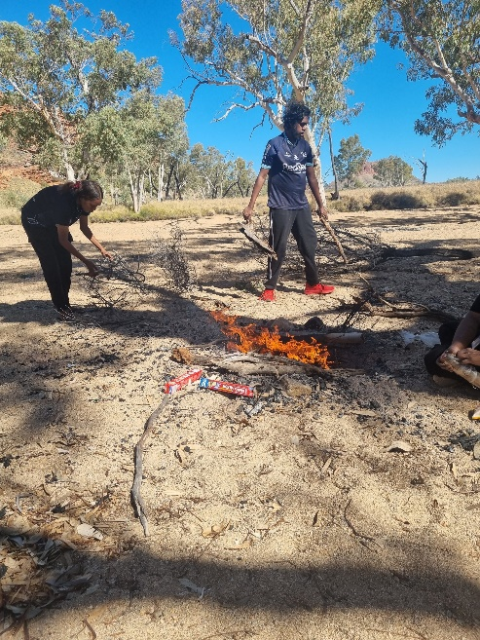

One of the young people with his aunt gathered firewood to prepare a fire for Kangaroo tail cooking.

Working Partnerships and Stakeholders

We stay connected to the community by attending stakeholder meetings, maintaining a collaborative approach by collaborating closely with multidisciplinary teams throughout Central Australian community to promote wellbeing, education, training, and employment engagement. We value our working partnerships and acknowledge the critical need to work together to provide positive outcomes of hope for young people.
The Refuge Staff frequently attends:
- Youth Interagency Strategies Coordination Group (YISCG)
- Central Australian Youth Justice (CAYJ)
- Youth Services Alice Springs (YSAS)
- Headspace Consortium Meeting
- Alice Springs Accommodation Action Group
- CAYLUS Reference Group
- Outreach and Accommodation Coordination Group
- Alice Springs Mental Health Professional Interagency
- Central Australian Family Violence and Sexual Assault Network (CAFVSAN)

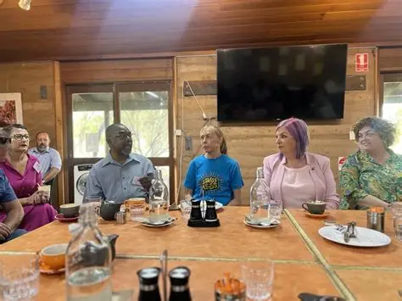

YOUTH HOUSING PROGRAM HIGHLIGHTS
Our Impact
In 2024–2025, the Youth Housing Program accommodated twenty young people, which included single people, families, and single mothers with children. The program provided 12-month leases, along with comprehensive support. Our comprehensive support system is designed to address the multifaceted challenges young people face when moving towards independence. Our resolute team provides a holistic suite of services, including:
- Tailored Case Management: Each young person receives personalized support, setting goals and navigating pathways towards their aspirations.
- Budgeting and Living Skills Workshops: From financial literacy to property maintenance, we equip clients with essential life skills for self-sufficiency.
- Routine Property Inspections: These inspections are not just about compliance; they are opportunities for supportive check-ins, ensuring properties are well-maintained, and clients are comfortable and safe.
- Assistance with Centrelink Payments: Navigating government support systems can be daunting. Our team provides crucial guidance and advocacy for Centrelink rent assistance and disability payments, ensuring financial stability.
- Support to apply for NT Priority Housing: We assist clients in applying for NT Priority Housing, helping to streamline their access to long-term housing solutions.

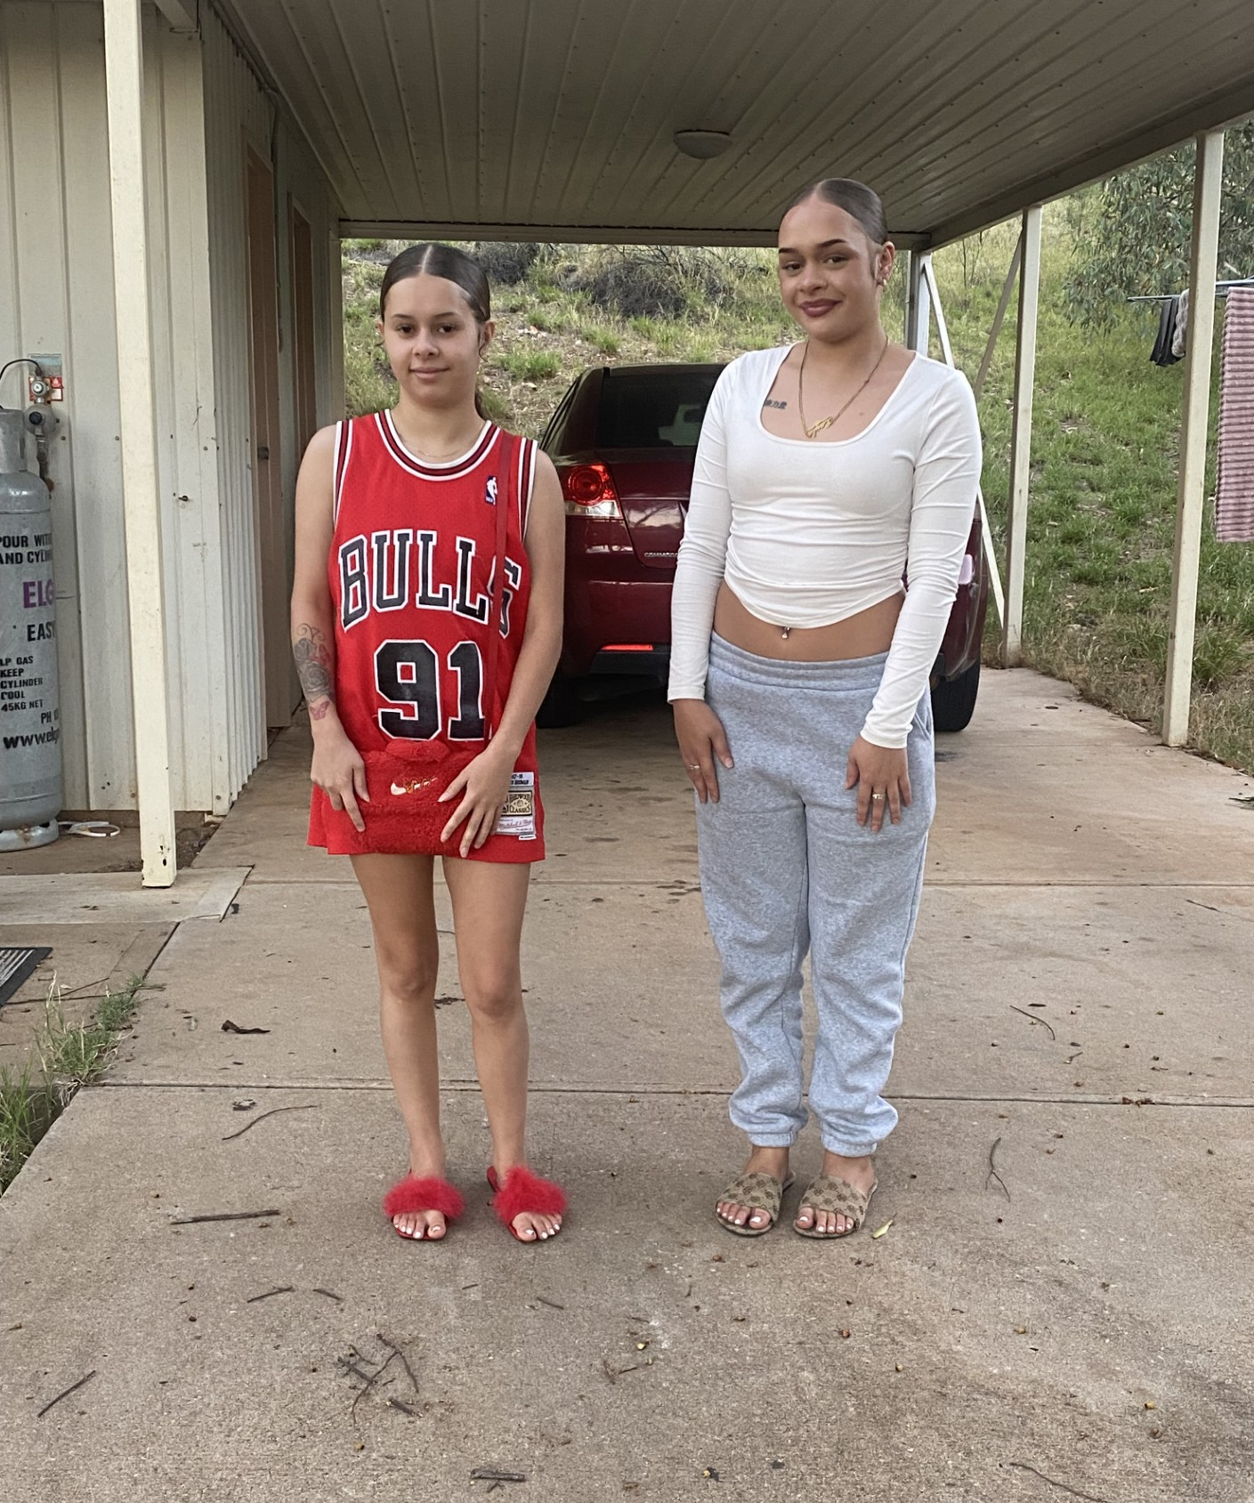
Two sisters in the Youth Housing Program at their house
Key Developments and Achievements

- Transformative Partnership with The Mobilise Kickstarter Program:
- A pivotal achievement for ASYASS has been the establishment of our new partnership with the Mobilise Kickstarter Program. This new collaboration has proven to be transformative, significantly easing the financial burden on our clients and accelerating their journey towards secure housing.
- The Program provides crucial financial support, covering bonds, rent, utilities, and other essential household items. This "kickstart" supports clients as they move into independent living arrangements.
- ASYASS has successfully referred several new tenants to this program, enabling them to secure housing quicker and alleviating the stress of applying for bond loans and prolonged waiting periods.
- Property Security Upgrades:
- ASYASS has begun a series of security upgrades at the properties, including the installation of security lighting, security cameras and improving gate security at one of the unit complexes.
- Partnership with Anglicare:
- The new collaboration with Anglicare broadens the support services available to our clients, including:
- Engagement with school and training opportunities.
- Referrals for job support, mental health services, and clinic appointments.
- Facilitating collaborative discussions with families to address potential friction points.
- Further development of living skills through discussions and activities is important.

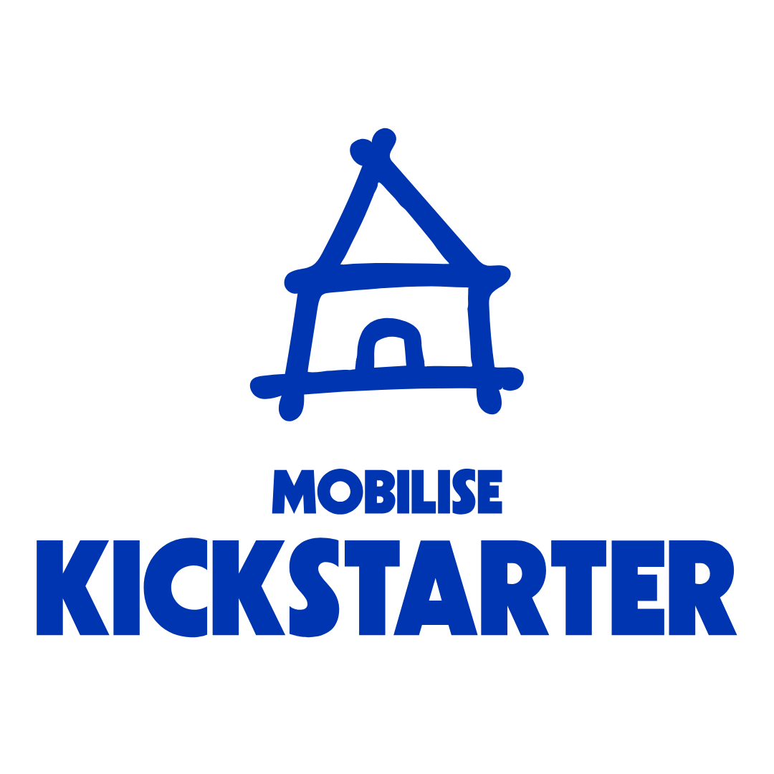

ASYASS UPDATES
Community Engagement – Homelessness Week

ASYASS participated and attended a community engagement event for homelessness week. This event provided an opportunity for ASYASS to raise awareness about our services and connect with other organizations working in the sector. It allowed us to promote the critical work we do and build valuable networks with like-minded services focused on homelessness and housing support.

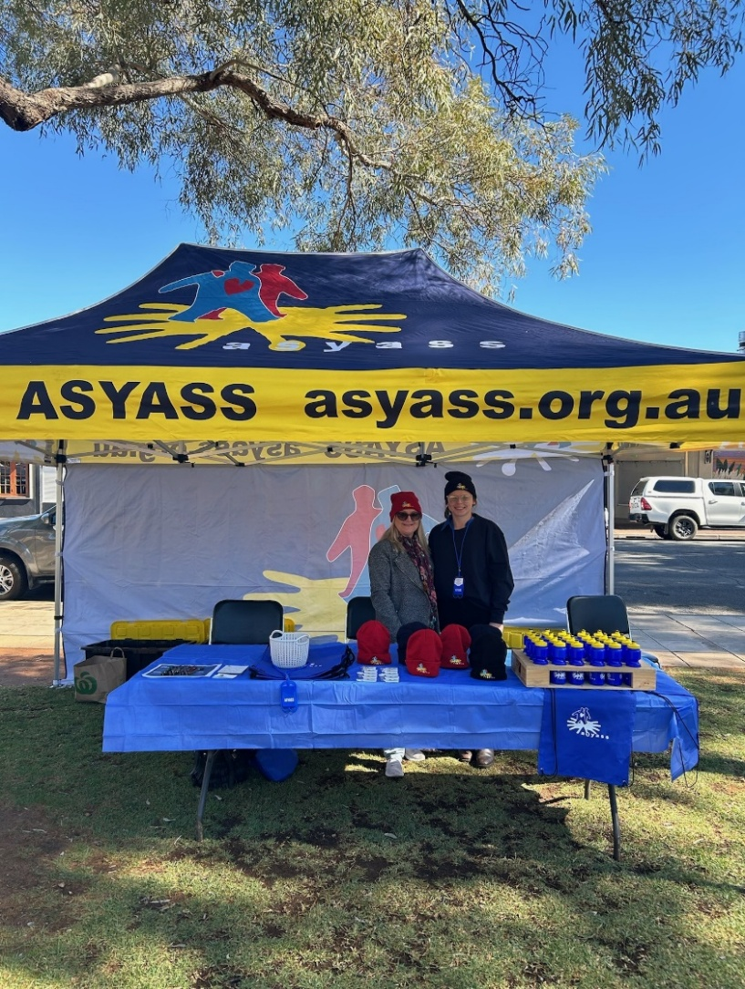

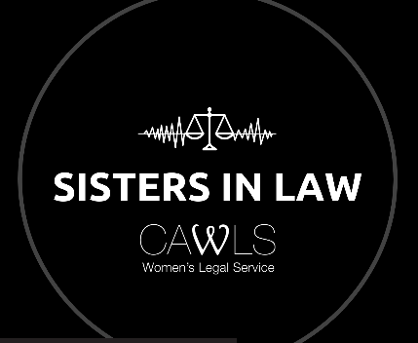
Sisters in Law

ASYASS was invited to participate in a 30-minute segment on 8CCC Radio, hosted by CAWLS – Central Australian Women’s Legal Service. During the episode, we discussed the programs that ASYASS offers, and the referral pathways available to those seeking support.
https://www.8ccc.com.au/programs/sistersinlaw/

National Homelessness Conference
The Crisis Refuge Case Manager was invited to attend the National Homelessness Conference in Gold Coast in June 2025, alongside fellow Northern Territory Services, including Mission Australia, NT Shelter, Catholic Care and CAAPS Aboriginal Corporation. This was an opportunity to represent Alice Springs and hear from homelessness, housing and social services across the world and be a part of the homelessness solution.
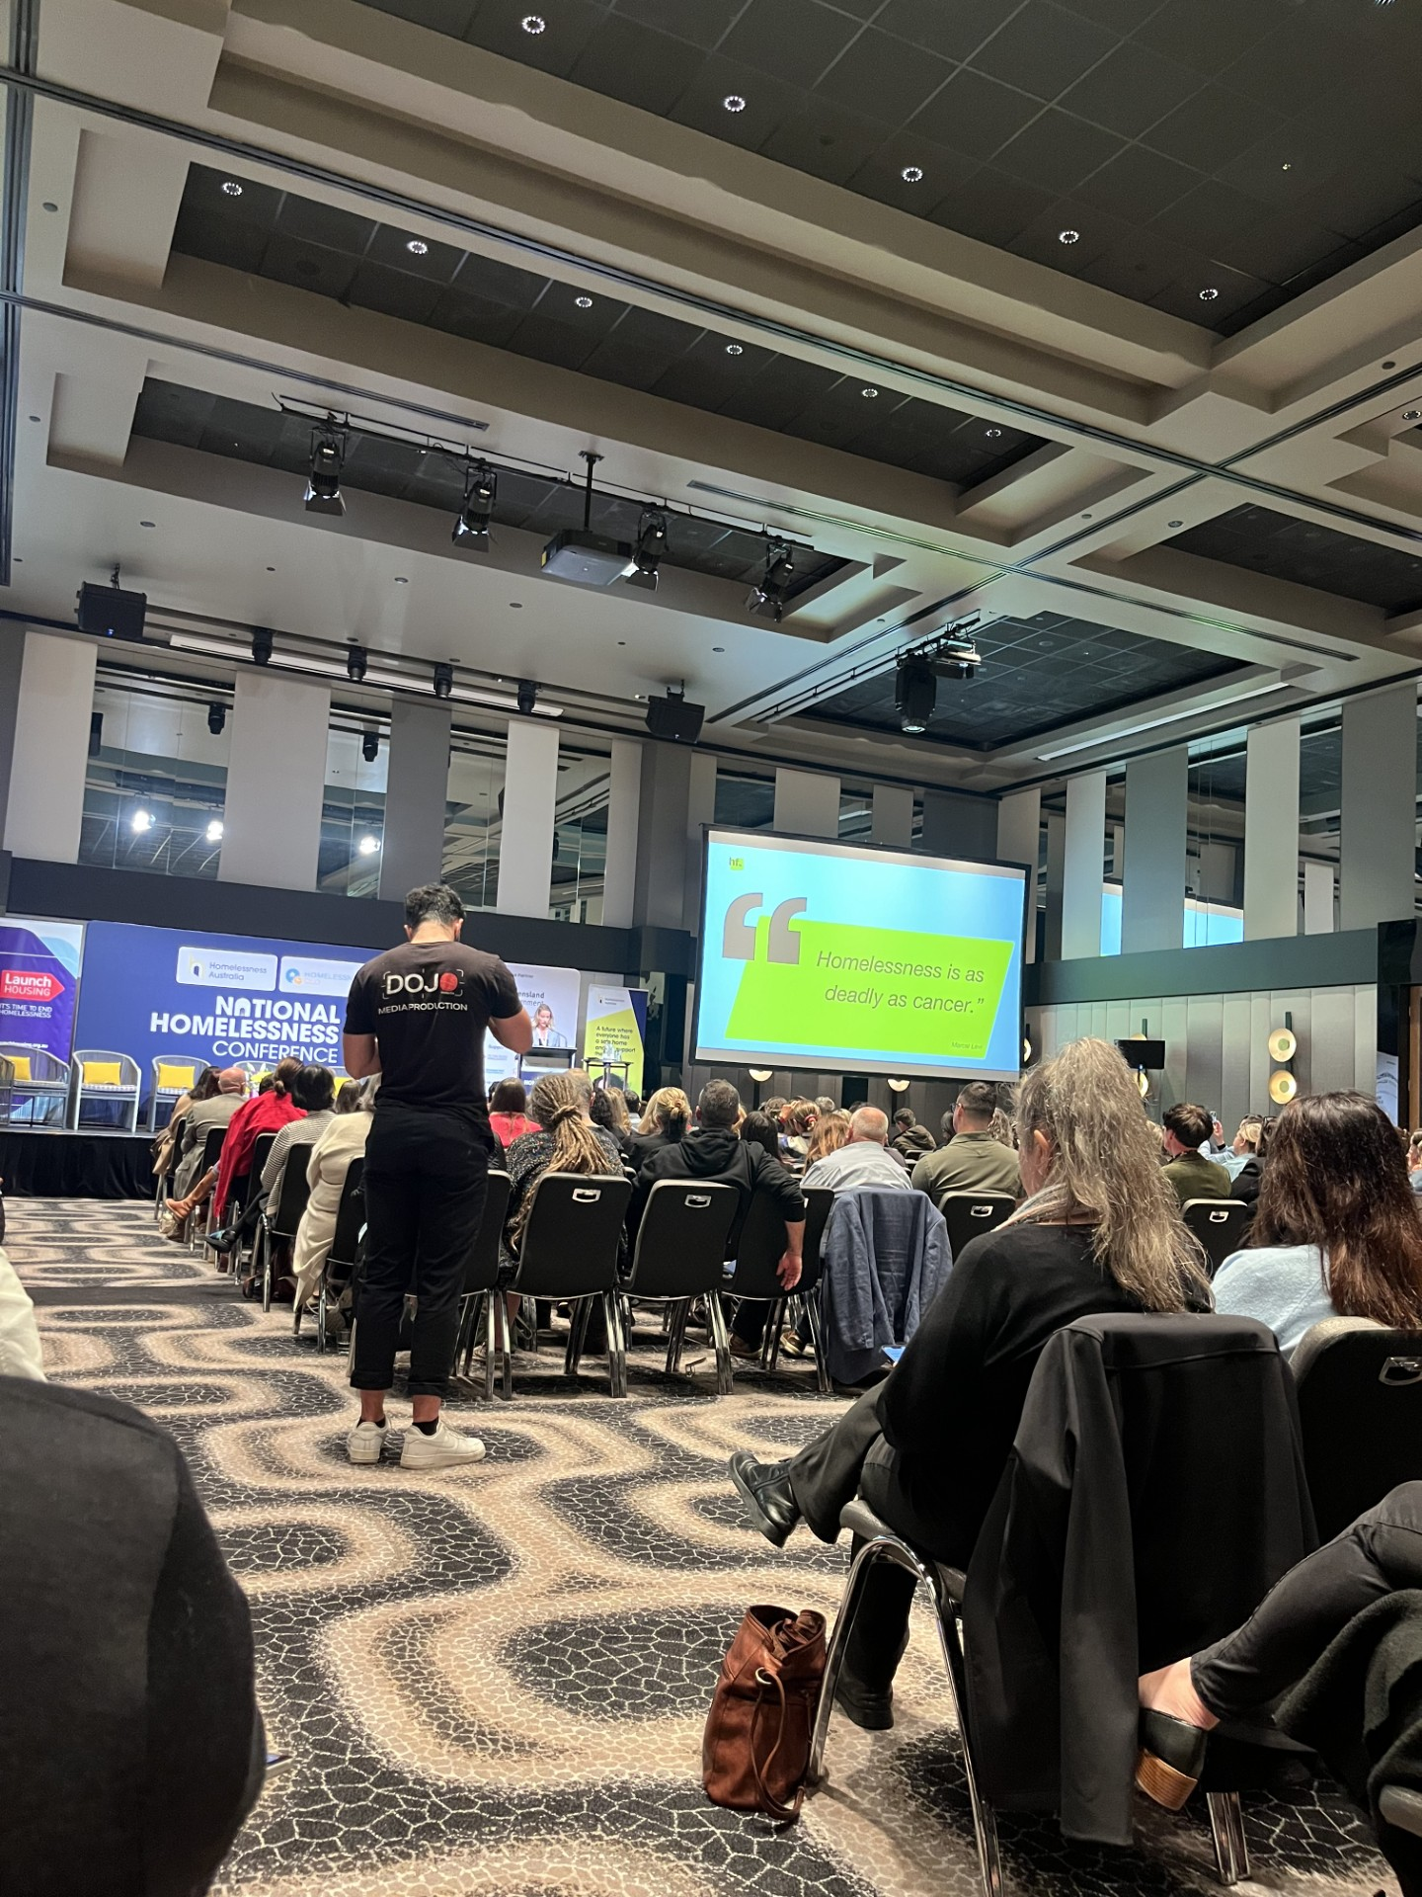

Community Partnership with Services Australia

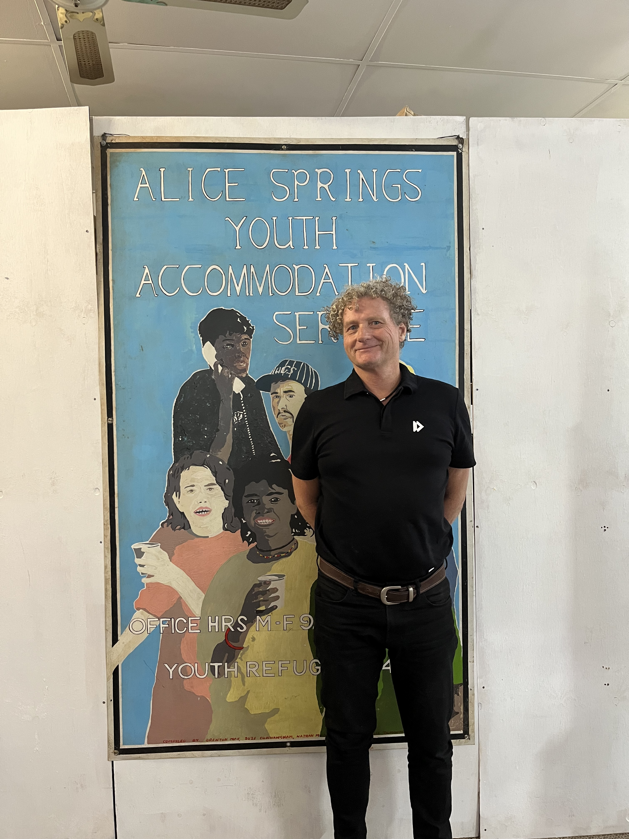
ASYASS works in collaboration with stakeholders across the community to achieve individual outcomes for as many young people as possible. Each young person that come through our doors at either Ampe Akweke, Crisis Refuge, On Track or Youth Housing Program are supported to obtain financial assistance and advice by a Community Partnership Specialist Officer from Services Australia who is located at ASYASS' main office, to provide tailored, end-to-end services to our young people on fortnightly basis. Each young person receives support to access Centrelink and Medicare benefits. Among the young people that we support at ASYASS, most of them face challenges with having little to no ID and no financial resources to obtain ID.

For example, Ampe Akweke supported a 16-year-old pregnant woman who had no income, had limited family support and no form of identification. Through extensive case management and collaboration with the Specialist Officer, the young woman was able to obtain Centrelink benefits and purchase her own birth certificate. Having the Community Partnership Specialist Officer based at the ASYASS head office enables a significant percentage of our young people to receive immediate financial support and advice. The Specialist Officer also collaborates closely with a qualified Social Worker from Services Australia when required, providing our young people with further access to specialized support and advocacy.

Community Partnership with BIZCOM
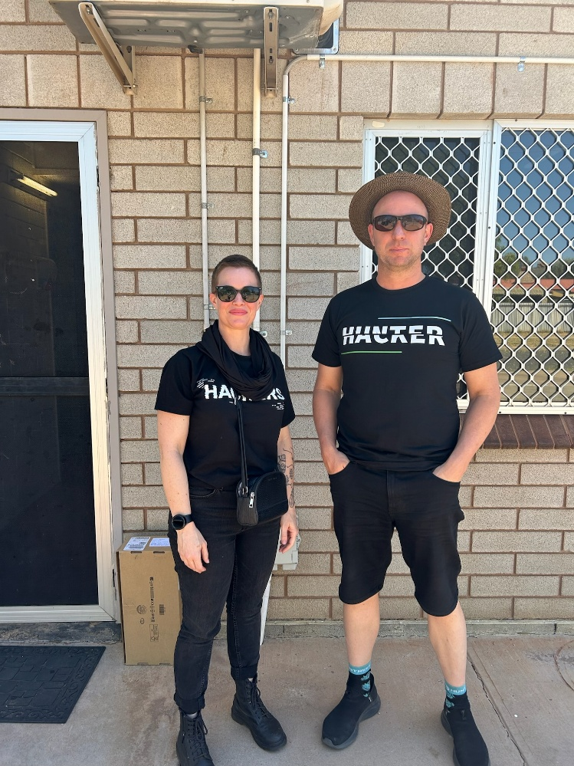

BIZCOM, a locally licensed telecommunications provider in Alice Springs, upgraded the Organizations computer system by enhancing hardware and increasing internet connectivity, thereby improving access to digital services and communication capabilities for clients and staff.

Professional Development
In November 2024, Ashlea ASYASS Chairperson, who is a Lawyer, facilitated a 2-day training course to educate staff about Mandatory Reporting in the Northern Territory. The training covered key topics including domestic and family violence and child protection obligations, ensuring staff are well-informed and equipped to meet their legal requirements.

A qualified Behavior Support Practitioner also led workshops for Crisis Refuge and On Track staff, focusing on enhancing their behavior management skills and providing strategies to effectively support clients in challenging situations.

Other training that staff participated in includes:
- Quality Management Systems and Internal Audit Training
- Applied Suicide Intervention Skills Training (ASIST)
- Understanding Coercive Control Training
- De-Escalation Training
- An Introduction to Strength Base Practice Training
- Exploring case management Training
- Mental Health First Aid Training

Funding Achievements
In June 2025, ASYASS successfully secured continued funding from the Department of Homelessness, ensuring the ongoing sustainability of our mission. With consistent funding for each program, ASYASS continues to provide crucial support and essential services to young people across Central Australia. The securing of ongoing funding has reinforced our ability to offer safe, stable accommodation for young people during times of need, helping us to make a lasting impact on their lives.

ASYASS is more than just a place to stay — it is a vital steppingstone toward stability, personal growth, and connection for vulnerable young people in our region. We stand alongside the young people across Central Australia offering guidance, and hope as they work towards a brighter future.

Thank you for walking with us.
- DCF - Department of Children and Families
- CAWLS – Central Australian Women's Legal Service
- NAAJA – North Australian Aboriginal Justice Agency
- NIAA
- NT Shelter
- Mobilize Kickstarter
- Central Australia Aboriginal Congress
- Headspace
- Anglicare NT
- Apmere Mwerre Visitors Park
- Tangentyere Council
- Stuart Lodge
- Salvation Army
- MHACA – Mental Health Association of Central Australia
- WOSSCA – Women's Safety Services of Central Australia
- Alukura Womens Health Clinic
- Alice Springs Hospital
- NT Police
- ANFPP – Australian Nurse Family Partnership Program
- Schools in the surrounding areas of Alice Springs
- Chamber of Commerce NT
- Services Australia
- Remote Strategy

